**Project Design Phase-I**

|  |
| --- |
| MQ-135 |
| MQ-4 |
| MQ-6 |
| **TTEMPERATURE SENSOR** |

**Solution Architecture**

|  |
| --- |
| SOLAR PANEL |

|  |
| --- |
| IBM WATSON IOT PLATFORM |

|  |
| --- |
| WEB UI |

SOLAR INVERTER

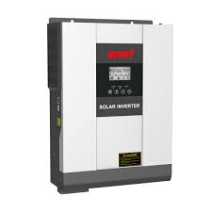

|  |
| --- |
| **ARDUINO UNO MICROCONTROLLER** |

|  |
| --- |
| GAS MODULE |

|  |
| --- |
|  |

|  |
| --- |
| CLOUDANT DB |

|  |
| --- |
| POWER STORAGE UNIT |

|  |
| --- |
|  |

|  |
| --- |
|  |